GLOBAL RECIPROCAL COLLEGES

COLLEGE OF COMPUTER STUDIES

SYSARC 1

SYSTEM INTEGRATION AND ARCHITECTURE 1

TILE-BASED PROGRAMMING

MOBILE GAME

A FEASIBILITY STUDY

PRESENTED TO THE COLLEGE OF COMPUTER STUDIES OF GLOBAL RECIPROCAL COLLEGES

IN PARTIAL FULFILLMENT OF THE REQUIREMENTS FOR THE DEGREE OF BACHELOR OF SCIENCE IN INFORMATION TECHNOLOGY

ATON, KIMPEE M.

CASTILLANO, GERALDYN R.

CORTEZ, HANNY I.

ISIP, JERICK RUPERT D.

PANTUA, RYAN C.

SALIBIO, CRISTIAN PAUL L.

REINERIO Z. QUINTO, JR.

ADVISER

2ND SEMESTER ACADEMIC YEAR 2024-2025

**Table of Contents**

1. Acknowledgements 4
2. Dedication 5
3. Introduction 6
4. Scope and Objectives 7
5. Project Name and Description ‎Tile 7
6. Project Objectives 8
7. Project Deliverables 10
8. Project Scope 11
9. Project Constraints: 12
10. Model for Study 13
11. Statement of the Problem 14
12. Code Conquest: Addressing These Issues Through Gameplay 15
13. Why Code Conquest is Considered a System 17
14. Proposed System 18
15. Functional Decomposition Diagram 18
16. System Flowchart 19
17. Data Flow Diagram 25
18. Prototypes 27
19. Cost and Benefit Analysis 33
20. DEVELOPMENT COST 33
21. PERSONNEL COST 33
22. OTHER MISCELLANEOUS COST 34
23. TOTAL ESTIMATED DEVELOPMENT COST 34
24. Benefits from the system 35
25. Appendix 36
26. Data Dictionary 38

# Acknowledgements

First and foremost, we offer our sincerest gratitude to God for the guidance, strength, and perseverance He bestowed upon us throughout this feasibility study. His blessings enabled us to overcome challenges and complete this important undertaking.

We extend our deepest appreciation to our families for their unwavering support and understanding. Their encouragement and sacrifices allowed us to dedicate the necessary time and effort to this project. We are especially grateful for their emotional support during stressful periods

Our heartfelt thanks go to our mentors and stakeholders, whose expertise and insights were invaluable in shaping the direction and scope of this study. Their feedback on our methodology and insights into market trends proved crucial.

Special thanks to the creators of Bookworm, whose clever use of tile-based interaction inspired the core mechanics of this project. The game's engaging format helped shape the concept of learning through visual and interactive design.

Finally, we acknowledge the contributions of each member of our group. We faced challenges and differing perspectives, but through collaboration and mutual respect, we successfully navigated these hurdles and achieved our shared goal. The teamwork and camaraderie developed during this project will be a cherished memory.

# Dedication

This feasibility study is dedicated to our parents, whose love, support, and belief in our abilities have been the foundation of our success. Their unwavering encouragement and sacrifices have made this achievement possible.

We also dedicate this work to future innovators and learners, hoping it will contribute to progress and inspire new ideas. This study represents our commitment to innovation and its potential to make a positive impact.

# Introduction

Games have a unique ability to evoke nostalgia, transporting us back to fond memories of childhood play, friendly competitions, and bonding moments with family, friends, and colleagues. Whether it's the thrill of victory or the agony of defeat, games have a way of creating lasting impressions that stay with us long after the game is over. However, despite their widespread popularity and impact, games are not without their complexities. One of the most enduring and challenging questions surrounding games is: what exactly are they, and how can we define them.

Defining games can be complex due to various interpretations. Notable philosophers and game designers have offered distinct perspectives on the nature of games. Bernard Suits views games as voluntary attempts to overcome unnecessary obstacles, emphasizing player agency and rule-governed challenges. In contrast, Roger Caillois defines games as fun, separate, uncertain, and non-productive activities governed by rules. Other definitions focus on player decision-making, such as Sid Meier's notion of games as a series of interesting decisions, and Keith Burgun's emphasis on ambiguous, meaningful choices. Jesse Schell's definition highlights games as problem-solving activities approached with a playful attitude, suggesting that gameplay can be both enjoyable and productive. These diverse perspectives underscore the multifaceted nature of games.

At its core, a game can be seen as a model for interaction, providing a structured environment in which players can engage with each other and the game itself. Games offer choices, present challenges, and require decision-making, all of which contribute to a dynamic and engaging experience. The rules of a game serve as a framework, guiding player behavior and shaping the game's overall structure.

As we delve deeper into the world of games, it becomes clear that they are more than just a form of entertainment. Games have the power to bring people together, foster social connections, and provide a platform for creative expression. Whether we're playing solo or with others, games offer a unique opportunity for interaction, exploration, and discovery (Eng, Dave. 2024, April 16).

A game is a system because it has many parts that work together. These parts make the game fun and organized for the players. One important part is the mechanics. Mechanics are the rules of the game. They tell players what to do, how to play, and how to win or lose. Another part is the resources. These are things like music, sounds, pictures, and videos. They make the game look and sound better and help players enjoy the game more.

There are also important systems that help the game work, like the rendering system that shows the graphics, the audio system that plays music and sounds, and the input system that lets players control the game. These systems make sure the game runs well on the computer or phone. All these parts work together. If one part is missing, the game will not be complete. The game needs all the parts to work well so players can have a good experience.

Games have a unique effect on how people experience learning and problem-solving. They create a safe and engaging environment where players can experiment, make mistakes, and try different strategies without fear of failure. Games also provide clear goals, feedback, and rewards, which keep players motivated and focused. The interactive nature of games allows players to learn by doing, which can make concepts easier to understand and remember compared to traditional methods.

This project will use these strengths of games to create a better learning experience. By turning coding lessons into a game, the project aims to make programming feel less intimidating and more enjoyable. The use of game mechanics such as tile-based coding and turn-based play will give players the freedom to explore, make mistakes, and learn at their own pace, while still feeling challenged and rewarded. This approach takes advantage of how games affect player experience to make learning to code more effective and engaging.

# Scope and Objectives

## Project Name and Description ‎Tile

**Game Title:** Code Conquest: The Adventure Game

**Description:**  
**Code Conquest** is a mobile game designed to teach Python programming through interactive, tile-based coding mechanics. The game covers key programming concepts such as variables, data types, and data structures, using a turn-based battle system. Players click tiles to build valid Python code—correct code damages enemies, while incorrect code results in counterattacks. This approach gamifies learning, providing engaging, scenario-based challenges that reinforce programming logic.

Inspired by *Bookworm Adventure*, the game teaches programming in the same way *Bookworm* teaches vocabulary, through progressively challenging puzzles. It follows a similar structure, with increasing difficulty and challenges that help players learn new concepts and reinforce their understanding.

## **Project Objectives**

The primary objective of this project is to create an interactive learning environment where users can develop their programming skills in a gamified setting. The game will guide players through a series of progressively challenging scenarios that focus on fundamental programming concepts. Each scenario will introduce a new concept and challenge the player to apply that concept in order to proceed to the next level.

The specific objectives of this project are as follows:

* **Create an Engaging Learning Experience**

Develop a turn-based, tile-based game that integrates educational content with engaging gameplay. The game will feature multiple levels, each focusing on a specific programming concept (e.g., variables, data types, control flow, functions).

* **Teach Core Programming Concepts**

The game will cover foundational programming concepts, such as variables, data types, loops, conditionals, functions, and data structures, ensuring that players gain a solid understanding of these key concepts.

* **Facilitate Concept Mastery Through Repetition**

The game will be designed to introduce each concept multiple times, each time applying the concept in a slightly different context. This approach will help players reinforce their learning and master the concepts by revisiting them.

* **Provide Real-Time Feedback**

Players will receive immediate feedback on their code choices. Correct code will allow them to progress in the game, while incorrect code will result in penalties, such as enemy counterattacks. This will encourage learning through trial and error.

* **Design a User-Friendly Interface**

The game will have an intuitive interface, allowing players to focus on learning and problem-solving without being overwhelmed by complex controls or navigation. The layout will be designed for ease of use, even for beginners.

* **Track Mastery and Progress**

The system will implement competitive global rankings through Overall Mastery scores while displaying personal progress metrics including Scenario Scores (Speed, Accuracy, Efficiency) and Concept Proficiency exclusively in the Milestone Menu UI.

## **Project Deliverables**

* **Working Prototype**: A playable version of the game that includes at least one completed level with functional tile-based coding mechanics, user interface, and correct integration of programming concepts.
* **Concept Scenarios**: A series of scenarios focusing on core programming concepts (variables, data types, loops, functions, etc.), each offering multiple levels with different context for players to complete.
* **User Interface Design**: An intuitive, easy-to-navigate interface that helps players focus on learning, featuring clear visual cues for coding input and feedback.
* **Real-Time Feedback System**: A mechanism that provides immediate feedback on players’ code choices, helping them learn from mistakes and improve their understanding of programming concepts.
* **Mastery Leaderboard**: A feature that tracks and ranks players based on their overall mastery of programming concepts, encouraging continued learning and improvement.
* **Interactive Tutorial System**: A narrative-style, step-by-step guide led by in-game allies that teaches players how to use the interface and coding system. It features dialog-driven instructions with focused highlights on UI elements to ensure clarity and smooth onboarding.
* **Mastery Leaderboard System**: A real-time global ranking system that continuously updates and displays Overall Mastery scores for top players through Supabase integration, serving as competitive benchmarks visible to all users.
* **Milestone Progress Tracker**: A progress tracker that records and displays individual Scenario Scores and Concept Proficiency breakdowns, accessible only through each player's private Milestone menu.

## **Project Scope**

Code Conquest: The Adventure Game is a mobile-based, tile-based game designed to teach programming concepts through interactive coding challenges. The game focuses on providing an engaging, educational experience where players solve problems related to key programming concepts such as variables, data types, control structures, functions, and more.

**Features and Functions**

* **Interactive Coding Challenges**: Players will solve programming problems related to different concepts such as variables, data types, control structures, functions, and more.
* **Progressive Learning Levels**: The game will feature multiple levels, each focusing on a specific programming concept. These levels will progressively introduce new ways to apply each concept, starting with basic usage in Level 1 and gradually increasing in complexity. Each concept is revisited in varying contexts across different levels, reinforcing the player’s understanding and ensuring mastery through continuous practice and problem-solving.
* **Tile-Based Gameplay**: The player interacts with a tile-based game interface where each action corresponds to a specific code-related challenge.
* **Real-Time Feedback**: Players will receive feedback on their code, guiding them on errors and corrections after each input.
* **Concept-Specific Scenarios**: Each scenario will target a specific programming concept and be structured in increasing difficulty.
* **Mobile-Friendly Interface**: The game will be designed for mobile platforms, ensuring accessibility and usability on the go.
* **Player Progression**: Players will advance through levels by successfully writing and debugging code to defeat enemies and progress to new challenges.
* **Mastery Leaderboard**: The game will feature a leaderboard that ranks players based on their overall mastery of programming concepts. It will be used to measure and showcase players' learning progress, motivating them to continue improving their skills and knowledge.

## Project Constraints

* **Modular System Development**

Creating the levels (scenarios) for each concept may take longer than expected, as the modular system needed to organize these levels is not fully developed yet.

* **Authentication Limitations**

The Godot extension for Supabase and OAuth services (for social logins like Google or Facebook) are not currently available. This means we cannot use these services for user authentication at the moment. As an alternative, we will use Supabase’s built-in authentication method, but implementing OAuth in the future will take time.

* **Cross-Platform Availability**

While the game is currently being developed for mobile platforms, there is potential for the game to be expanded to other platforms in the future. This will depend on the progress made with the mobile version and its compatibility with other systems.

* **Human Resources**

There may be limitations in the development team, such as a lack of expertise in specific areas like design or specialized programming. In such cases, external hires will be considered, but this will also be limited by the project’s budget.

# Model for Study

**Bookworm Adventure** is a word puzzle game developed by *PopCap Games*, where players solve word puzzles to progress through an adventure storyline. The game is known for combining educational gameplay with fun, challenging mechanics, making it a popular choice among casual and young gamers.

**Game Functions**:

* *Word Puzzle Mechanics*: Players create words from a grid of letter tiles to complete puzzles and unlock new areas of the adventure.
* *Adventure Progression*: The game features a storyline that unfolds as the player advances through levels, with each stage offering different challenges.
* *Power-ups and Rewards*: Players earn power-ups and other rewards that assist in solving puzzles and progressing faster through levels.
* *Character Development*: The game offers character progression through the completion of challenges, with different levels and difficulty settings.

# Statement of the Problem

Many beginner programming students, whether enrolled in schools, universities, or self-learning—struggle not only with understanding core programming concepts like variables, data types, conditionals, and loops, but also with writing code itself. The process of translating logic into correct syntax can feel overwhelming, especially when learning through lectures, textbooks, or static tutorials.

**Common Challenges Faced by Learners**

* Concepts are difficult to understand without visual, interactive examples.
* Students lack opportunities to practice coding in a meaningful or enjoyable way.
* Writing code from scratch feels intimidating, especially when mistakes lead to confusion rather than learning.
* Traditional teaching methods can feel dull or overly technical, reducing motivation.
* Delayed feedback and lack of progress tracking can make learning feel directionless.

These issues often result in poor performance, low confidence, and even dropping out of programming-related courses. Self-taught learners face the same challenges without structured guidance or engaging tools.

## Code Conquest: Addressing These Issues Through Gameplay

**Code Conquest: The Adventure Game** is designed to turn the process of learning to code into an engaging, interactive experience. Through a turn-based, tile-based system, players assemble real code to solve progressively challenging programming scenarios. The game emphasizes both concept understanding and hands-on coding practice by offering:

|  |  |  |
| --- | --- | --- |
| Game Features | Educational Challenges Addressed | How It Helps Learners |
| Tile-based Code Assembly | Writing code from scratch is intimidating | Players build logic using tiles, reducing syntax-related intimidation while still teaching structure. |
| Concept Scenario Levels | Concepts feel disconnected or too abstract | Each level introduces and reinforces one concept in a clear, focused way. |
| Delayed-but-Interactive Feedback | Feedback in traditional settings is too slow or unclear | Code is evaluated after submission, with clear results and guidance encouraging self-correction. |
| Mastery Tracking System | Students don’t know what they’ve actually learned | Tracks progress and concept mastery across levels to reinforce retention. |
| Turn-based Battle Mechanics | Lessons feel dry or overly academic | Engaging combat rewards correct logic, turning problem-solving into gameplay. |
| Skin Rewards and Unlockables | Learners lose interest easily without incentives | Visual rewards and level progression keep motivation high without distracting from learning. |
| Mobile-first Design | Not all learners have access to desktops | Optimized for mobile to make learning accessible on most devices. |
| Cloud-synced Progress (Supabase) | No continuity across sessions or devices | Player data is saved, so learners can continue anytime, anywhere. |

By gamifying code creation and practice, *Code Conquest* helps students move from passive understanding to active skill-building.

## Why Code Conquest is Considered a System

Modern educational games can function as complex systems due to their deep integration with both hardware and software layers. Like operating systems or development environments, they involve structured processes such as dynamic resource allocation, system-level dependencies, and interactive feedback loops. *Code Conquest: The Adventure Game* follows this approach—combining structured gameplay, educational logic, and backend integration to achieve its learning goals.

# Proposed System

## **Functional Decomposition Diagram**

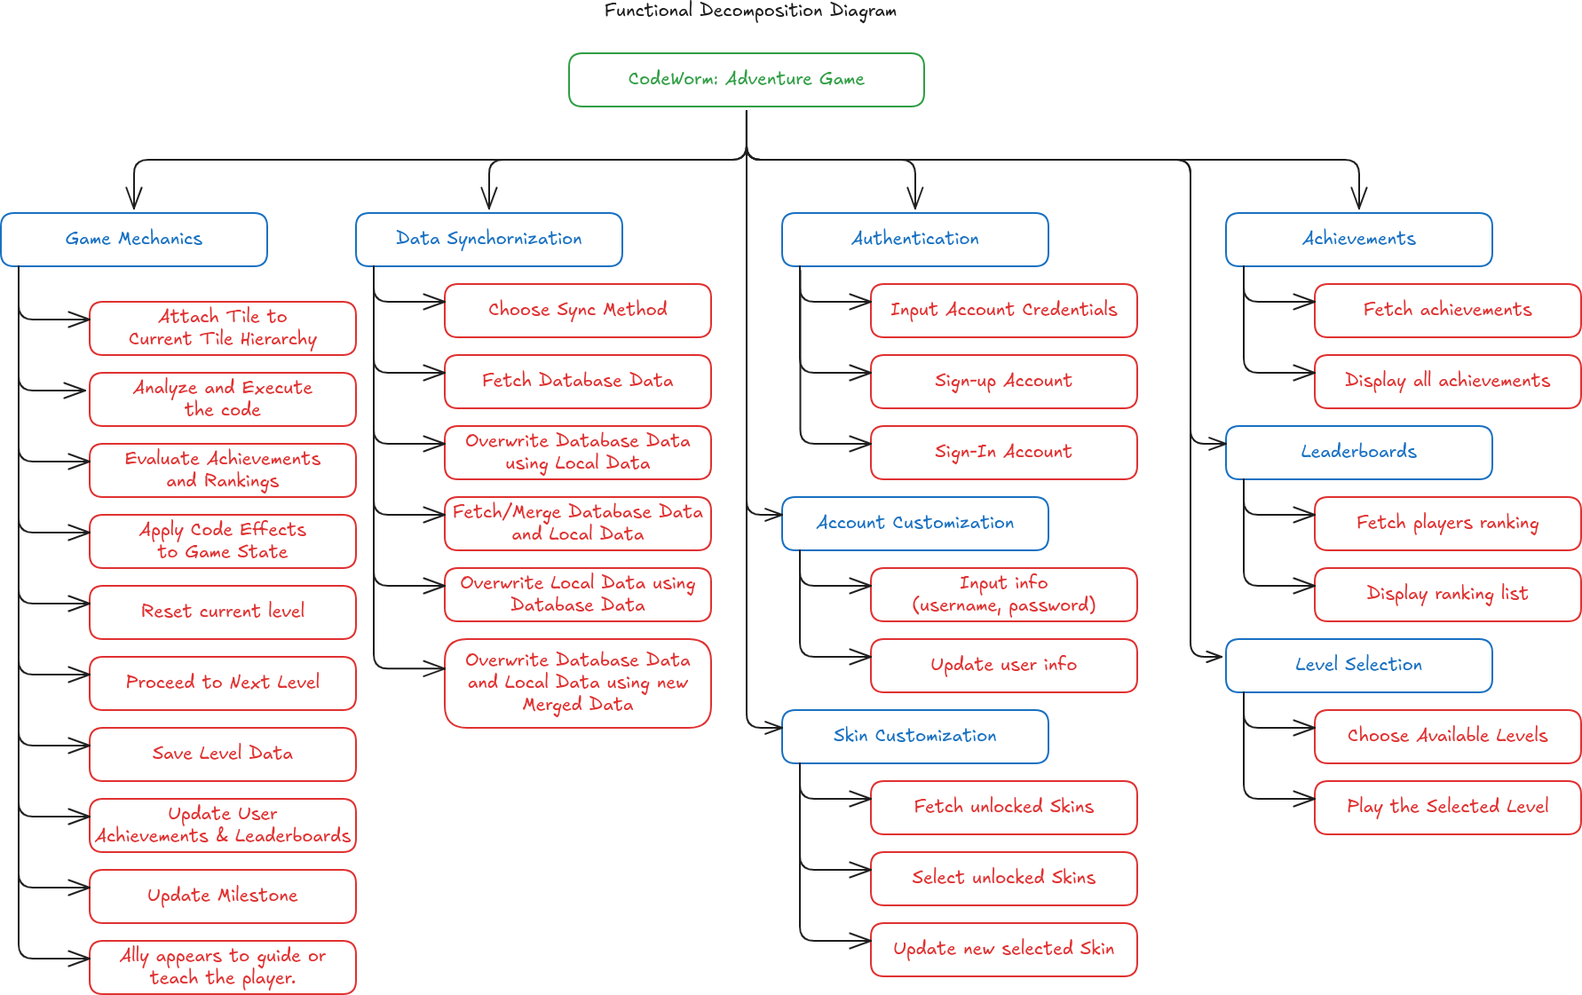

## **System Flowchart**

User Authentication

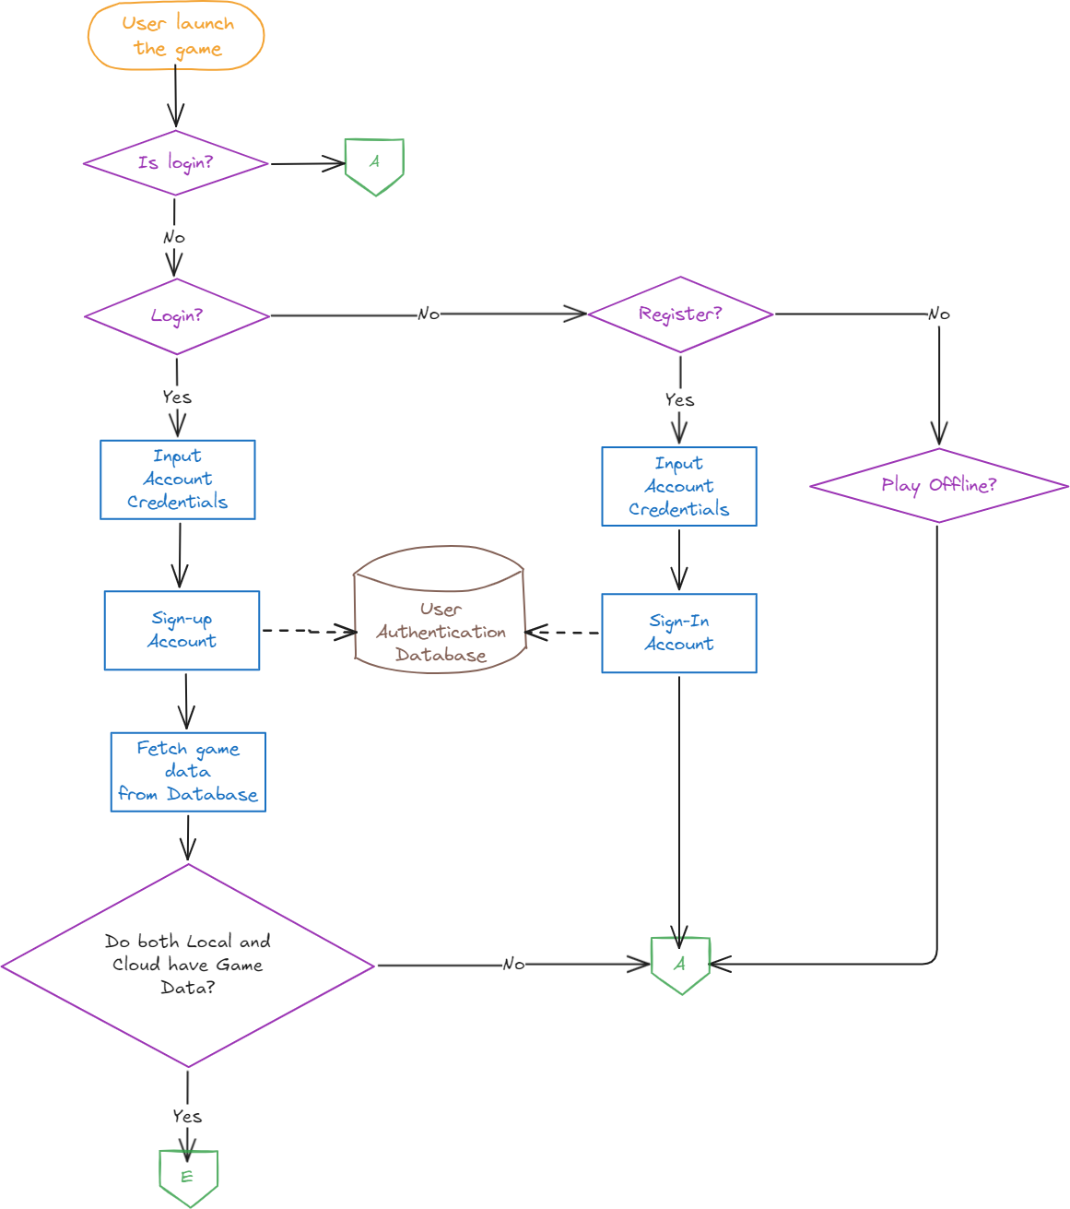

Data Synchronization

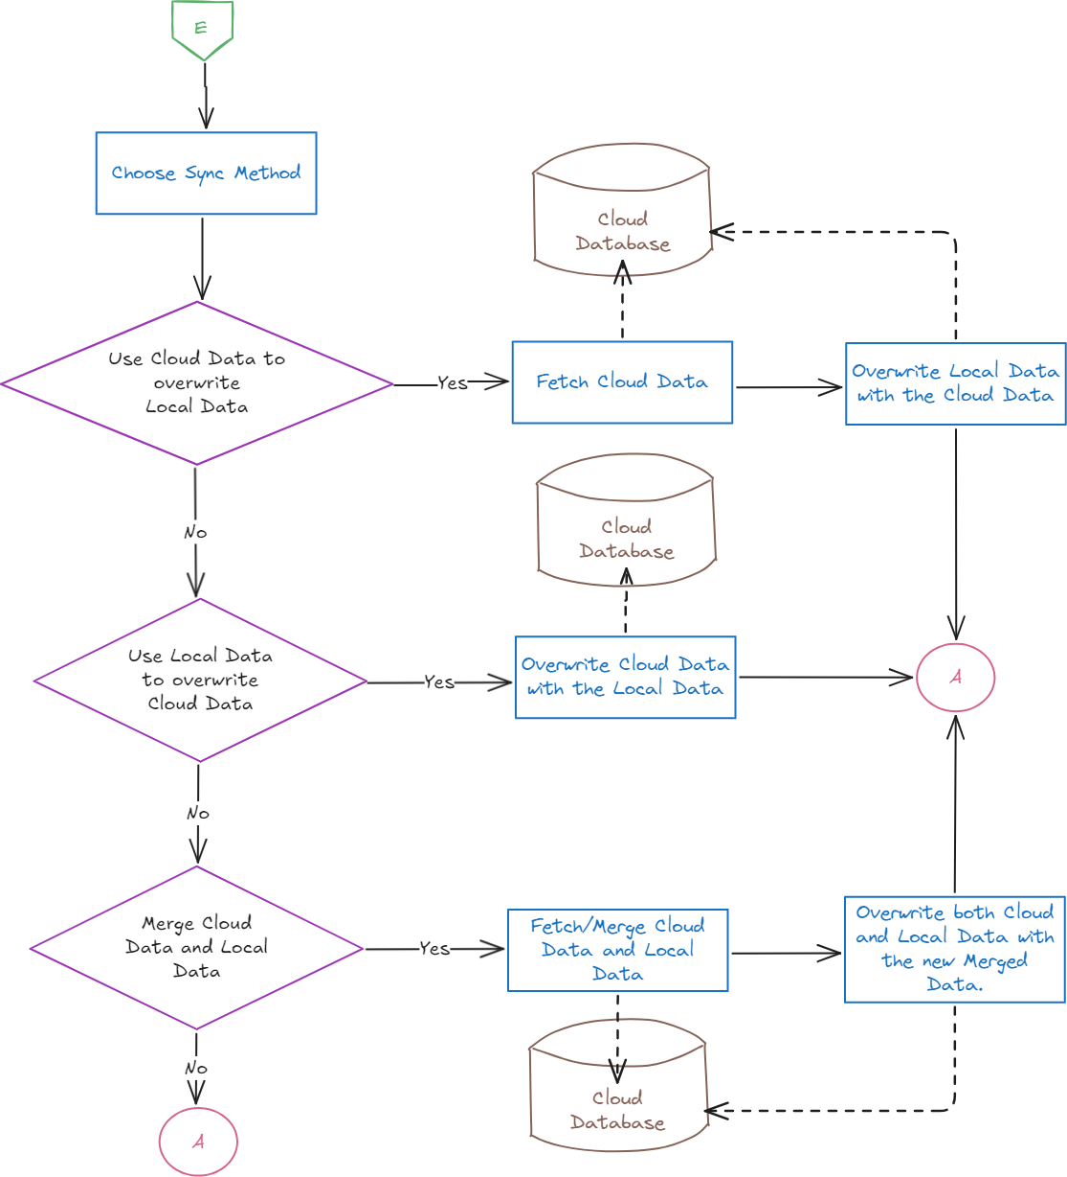

Play and Customization Menu

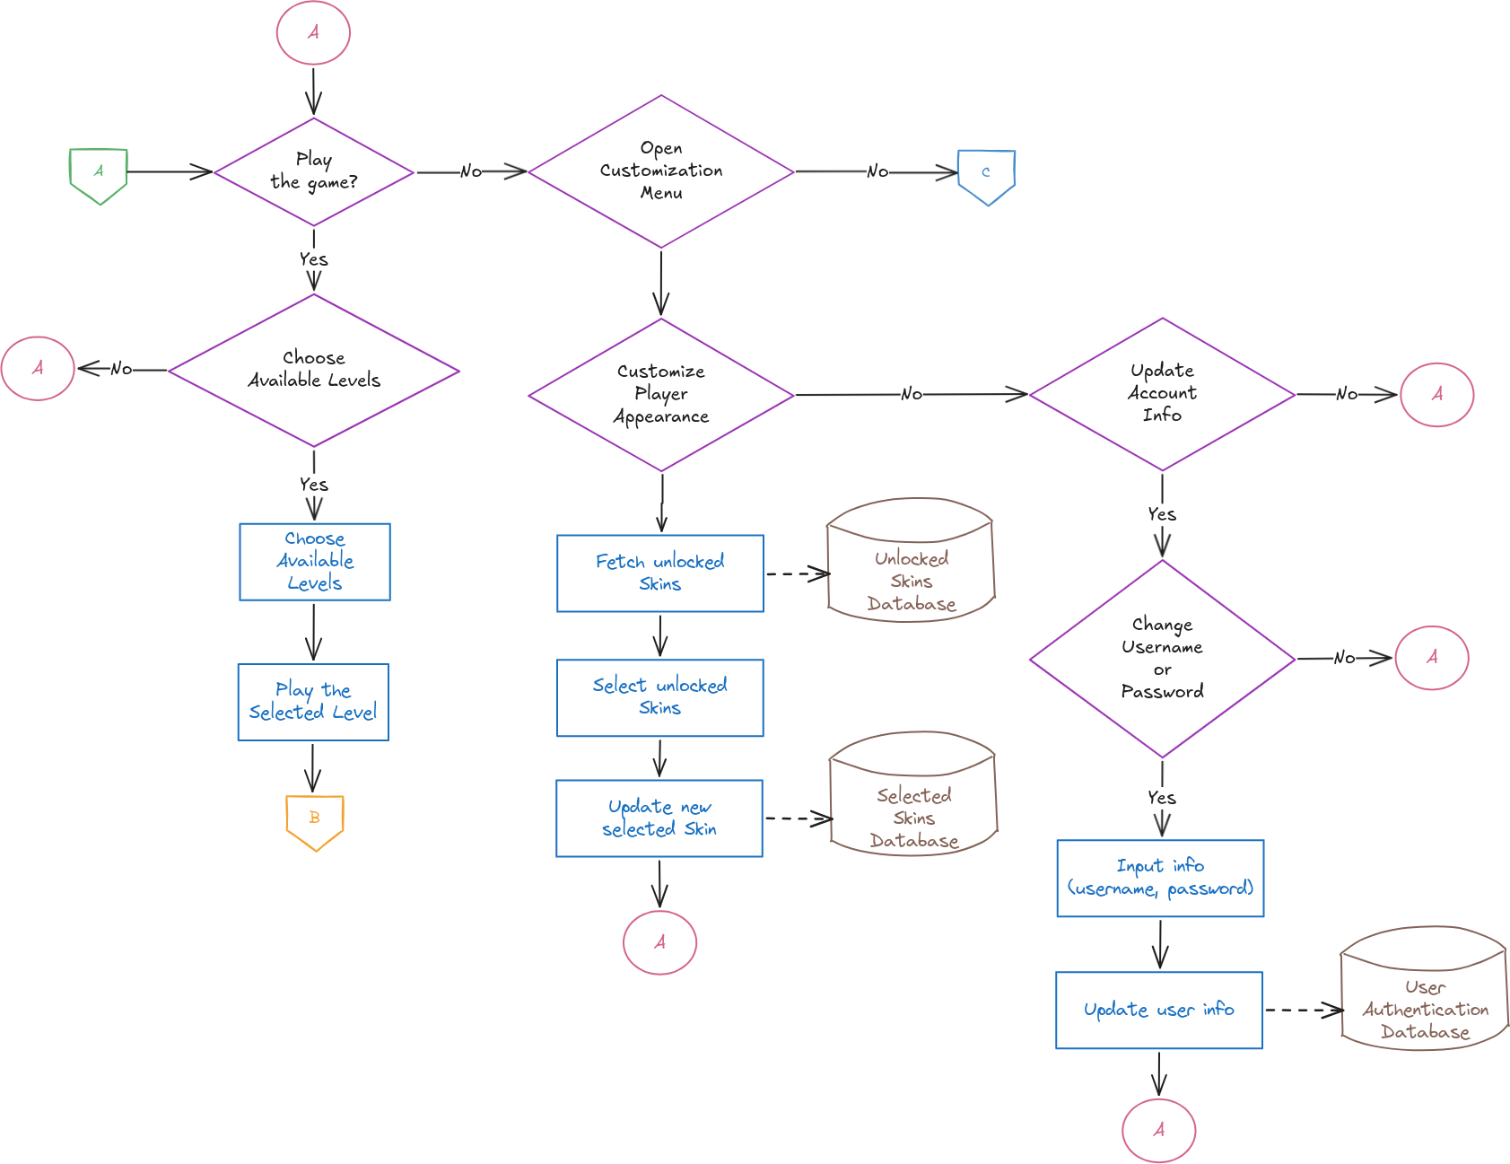

Leaderboards

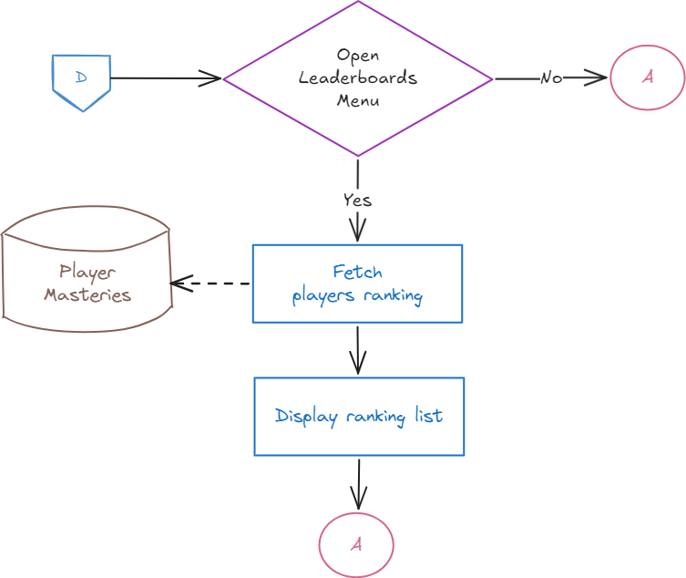

Progress-Quit

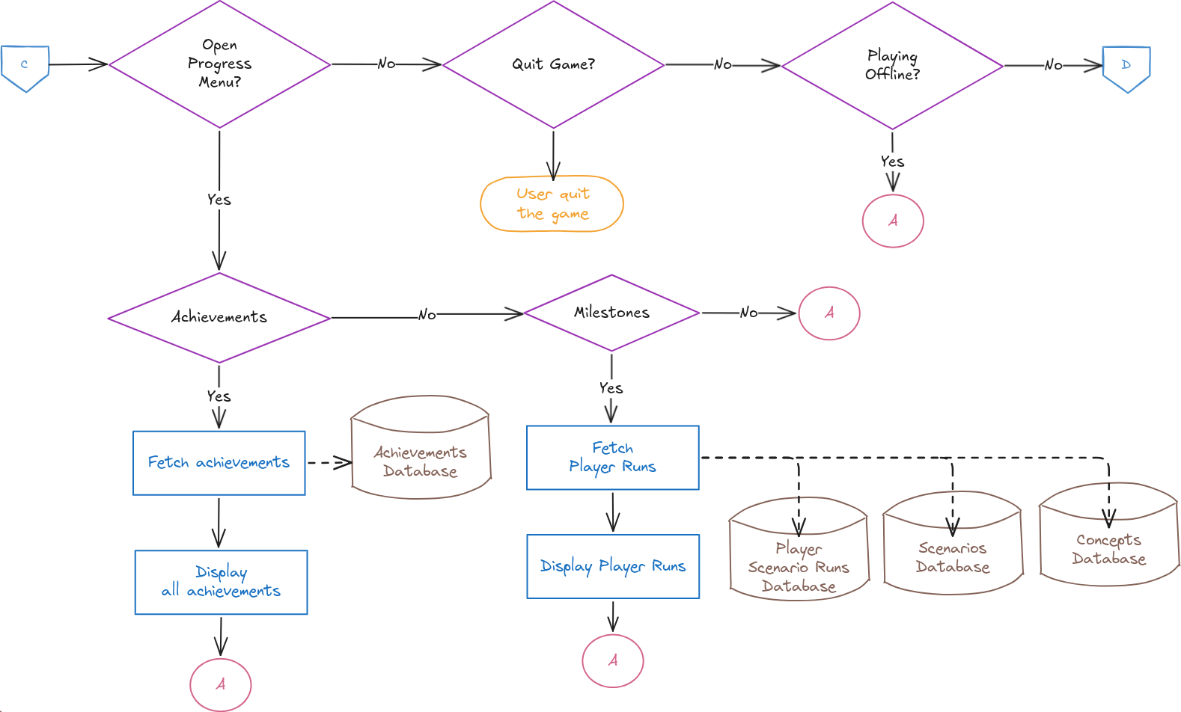

Gameplay

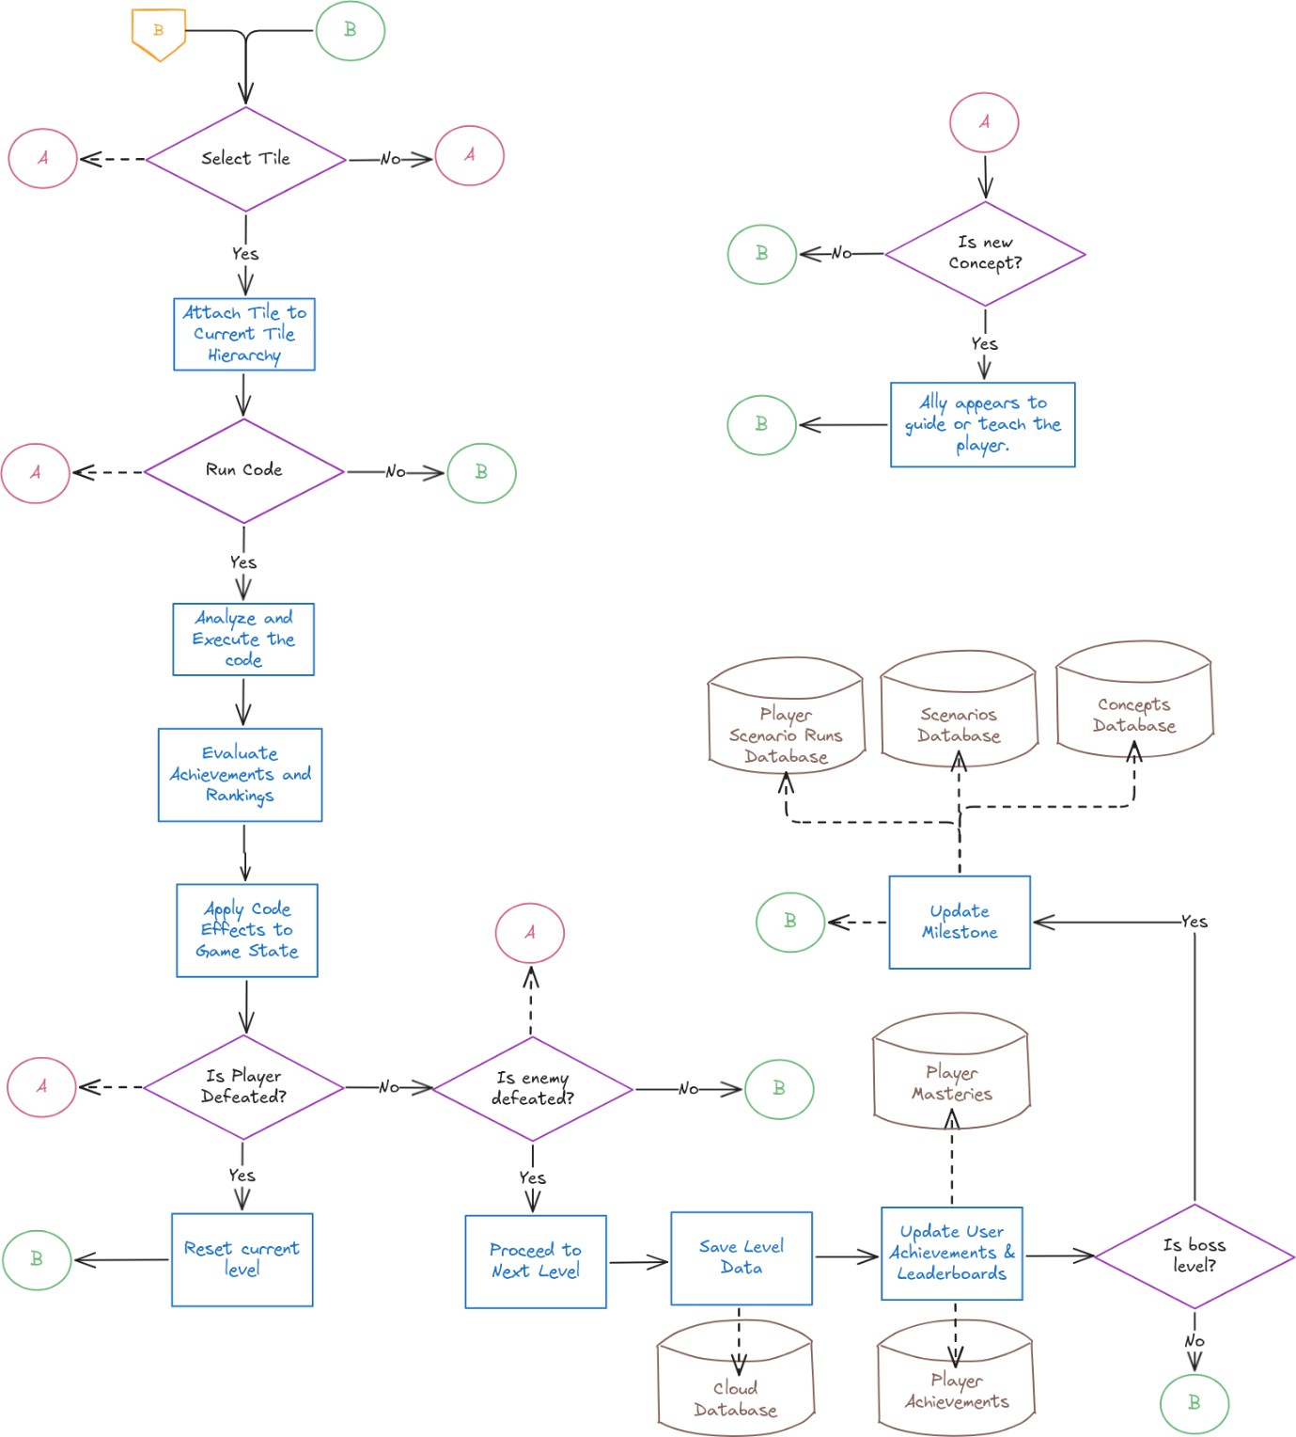

## Data Flow Diagram

DFD-0

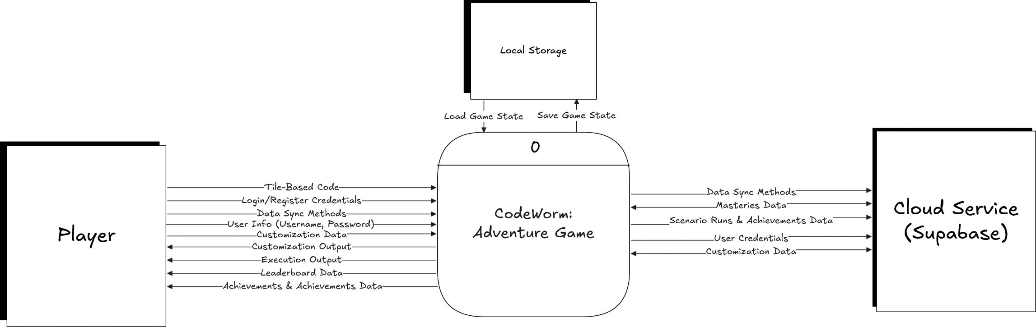

DFD-detailed

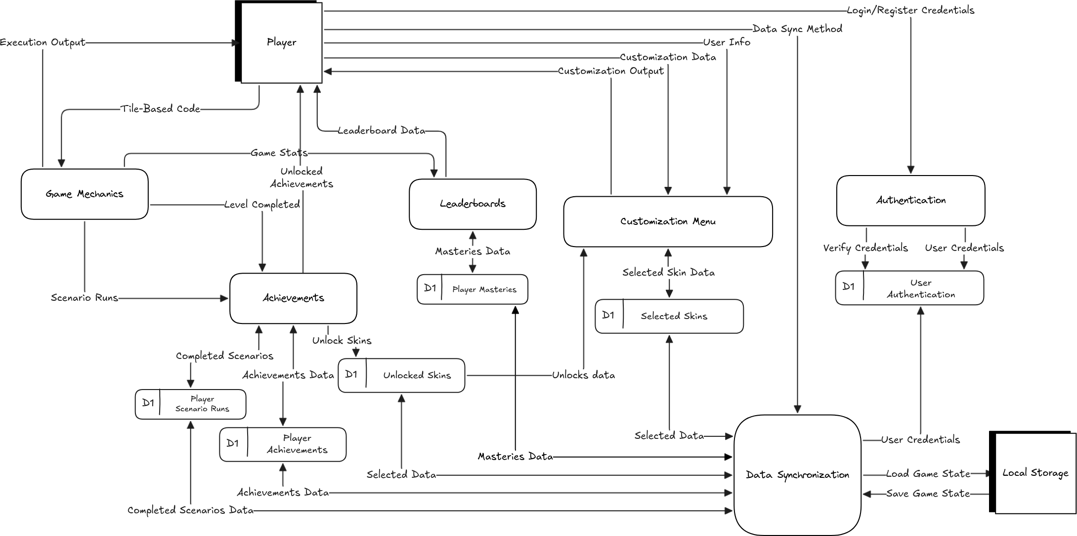

# Prototypes

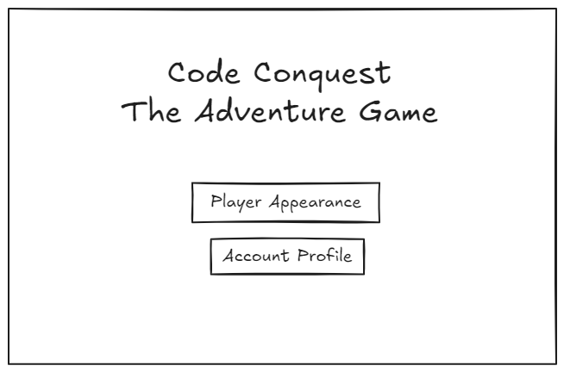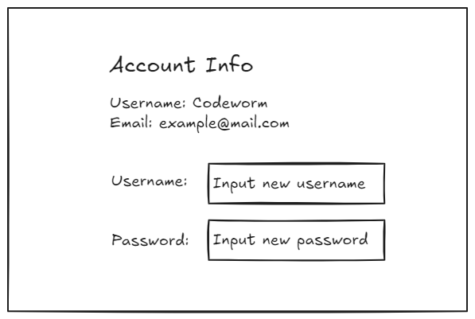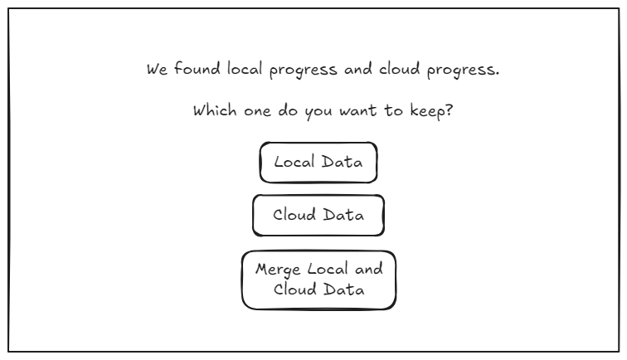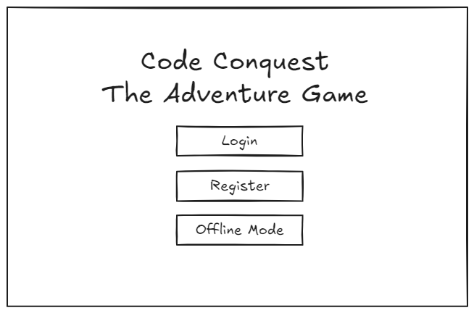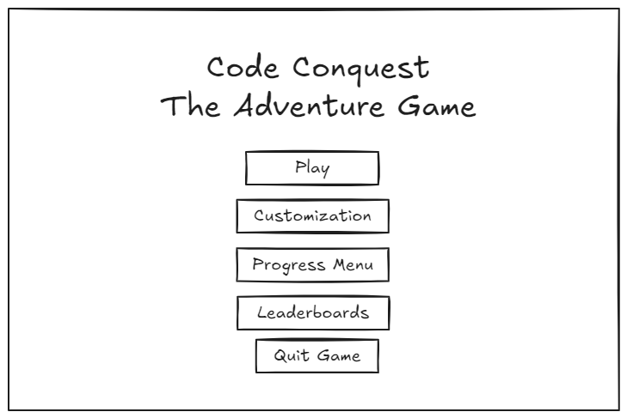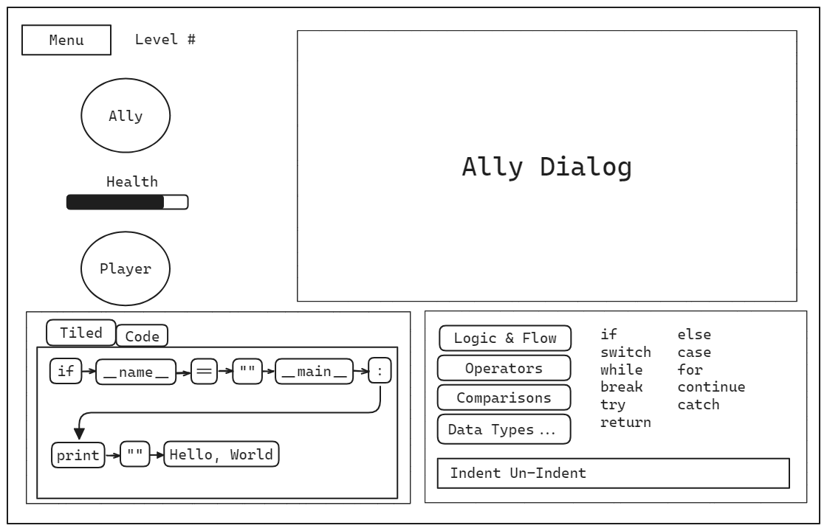

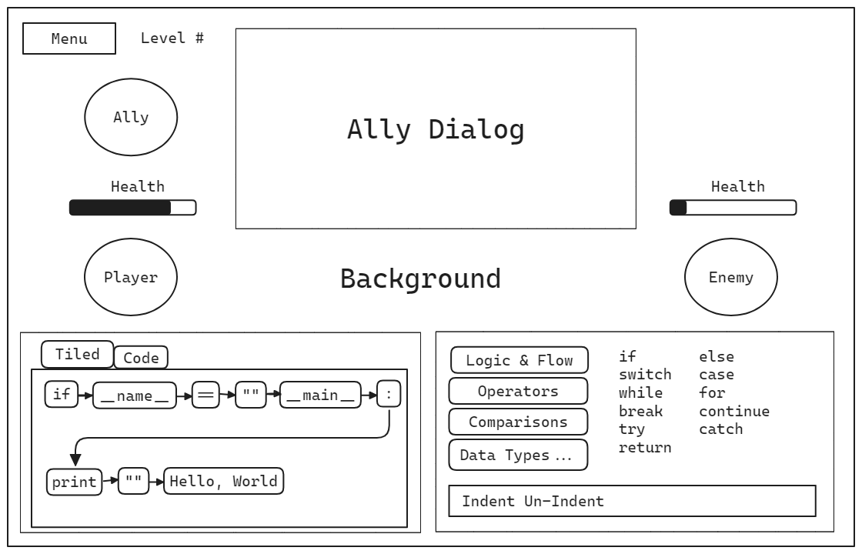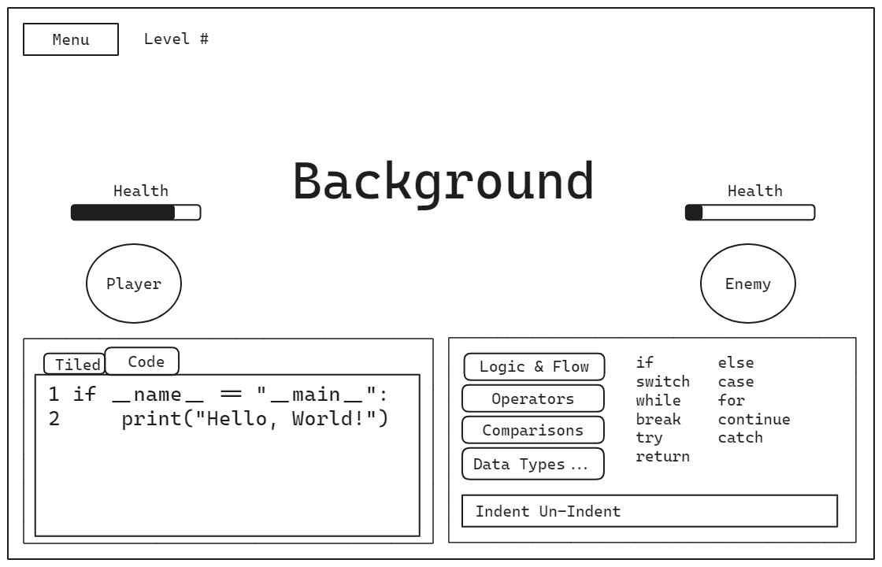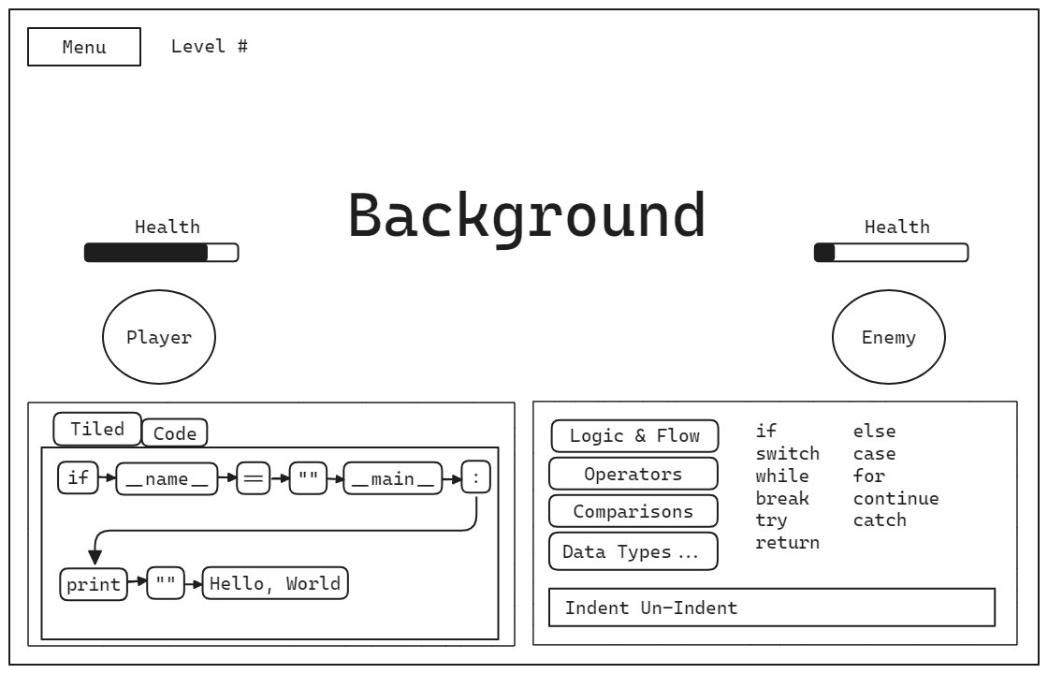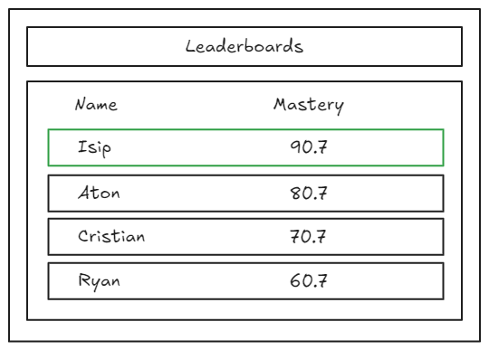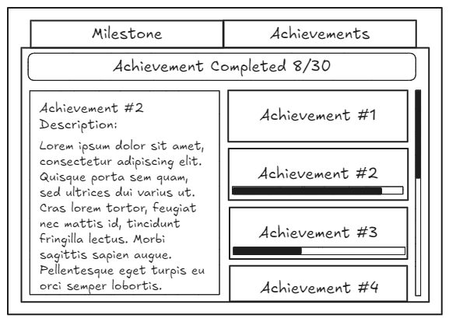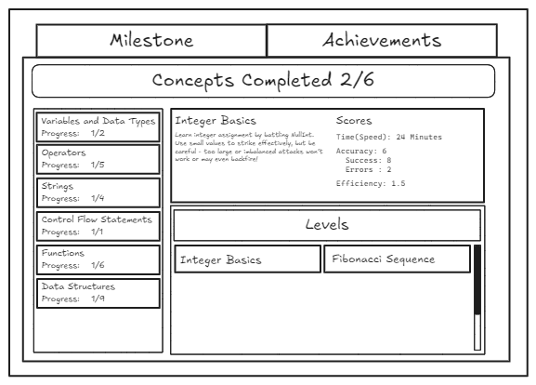

# Cost and Benefit Analysis

This cost and benefit analysis provide an estimated budget for game development, covering technical specifications, game assets, programming, personnel expenses, and miscellaneous costs such as electricity and internet. Depending on whether the project is developed solo or with freelance assistance, the total cost ranges from ₱11,150 to ₱40,460, ensuring resources are allocated efficiently for a smooth development process.

## **DEVELOPMENT COST**

|  |  |  |
| --- | --- | --- |
| Expense Category | Estimated Cost (PESO) | Description |
| Technical Specifications | ₱2,960 | Godot Game Engine (Free and Open Source).  Cloud-Service (Supabase - Free tier, but reserved budget for growth or subscription plan).  Android (for publishing on Google Play Store). |
| Game Assets | ₱5,000 | Creating/buying/downloading assets such as 2D/3D characters, animations, environments, and UI elements. |
| Game Programming + Prototyping | ₱15,000 | The programming effort will focus on testing the core mechanics (like tile-based coding, battle mechanics, etc.) and building the prototype with basic functionality. |

## **PERSONNEL COST**

|  |  |  |
| --- | --- | --- |
| Expense Category | Monthly Salary | Description |
| Game Programmer | ₱15,000 | Handles coding, implementing mechanics, and ensuring functionality. |
| 2D/3D Artist | ₱6,000 | If hiring a 2D artist for characters, backgrounds, UI, and animations. |
| Music & Sound Effects | ₱1,500 | If hiring a freelancer, otherwise, use free or cheap assets (e.g., OpenGameArt, Itch.io). |
| Game Testing | ₱1,000 | If hiring testers to find bugs and issues. |

## **OTHER MISCELLANEOUS COST**

|  |  |  |
| --- | --- | --- |
| Expense Category | Estimated Cost (PESO) | Description |
| Electricity and Utilities | ₱5,000 | The cost of powering workstations, servers, and other equipment during development. |
| Internet and Utilities | ₱2,500 | High-speed internet for collaboration, file sharing, and online testing, as well as communication tools like Zoom or Slack. |

## **TOTAL ESTIMATED DEVELOPMENT COST**

If solo or mostly in-house: **₱11,150**If with freelance help: **₱40,460**

## **Benefits from the system**

The system will bring several valuable benefits, including improved accessibility to engaging and interactive gameplay, enhanced user experience through well-designed assets and mechanics, and potential monetization opportunities if published successfully. Additionally, it fosters learning and creativity, supports community engagement, and allows for future scalability with cloud integration, making it adaptable for growth and new features.

* **Enhanced Accessibility** – Ensures users can easily interact with the game, whether on mobile or desktop.
* **Engaging User Experience** – Well-designed assets, animations, and mechanics create an immersive and enjoyable gameplay experience.
* **Learning and Skill Development** – Encourages logical thinking, problem-solving, and creativity, especially if incorporating educational aspects.
* **Community Engagement** – Allows users to connect and interact, fostering a dedicated player base.
* **Scalability and Future Growth** – Cloud integration enables easy expansion, updates, and additional features over time.
* **Cross-Platform Compatibility** – Optimized for publishing on different platforms, increasing potential reach.
* **Customization and Flexibility** – Allows room for modifying gameplay elements or introducing new mechanics based on user feedback.

# Appendix

A

* **Accuracy**: A score based on correct lines minus errors (higher = better).
* **Achievements**: Unlockable rewards for completing tasks.
* **Allies**: NPCs that introduce new programming concepts.
* **Analyzer**: A system that checks code syntax after 1.5 seconds of inactivity.
* **Authentication**: Secure player login/registration.

B

* **Battle Boosters**: Power-ups like resurrection or damage prevention.

C

* **Code-Window**: The area where players connect tiles to write code.
* **Concept Mastery**: Tracks player proficiency in programming topics.
* **Concept Proficiency**: Average skill in a specific programming concept.

D

* **Data Synchronization**: Cloud-saved progress across devices.

E

* **Efficiency**: Score based on damage dealt per tile used (higher = better).
* **Enemies**: Opponents defeated via coding.
* **Exceptions (Invalid Code)**: Errors that trigger enemy attacks.

G

* **Global Leaderboard**: Overall ranking based on *Overall Mastery*.
* **Grand Mastery**: Overall coding skill across all concepts.

H

* **HP (Health Points)**: Player/enemy health (0 HP = level reset).

I

* **Invalid Code**: Code that fails execution (triggers exceptions).

L

* **Leaderboards**: Ranks players by *Overall Mastery*.

M

* **Mastery Scores**: Tracks player skill categorized as Concept and Overall Mastery, an average of Normalized Scores and Concept Proficiency, respectively.
* **Milestone Menu**: The in-game interface displaying local player progress that includes *Scenario Scores* (Speed, Accuracy, Efficiency) for completed levels and *Concept Proficiency* breakdowns by programming concepts.

N

* **Normalized Scores**: Scenario Scores (Speed, Accuracy, Efficiency) scaled to 0-100 by comparing with the Best Scenario Scores of all Players.

O

* **Output-Window**: Displays execution results and errors.
* **Overall Mastery**: Average of all Concept Proficiencies, used for player rankings.

S

* **Speed**: Time taken to complete a level (lower = better).
* **Scenario**: Also known as a Level containing the usage of the concept taught.
* **Supabase**: It’s a Cloud-Service to be used as a Database with PostgreSQL

T

* **Tile-Window**: Panel displaying available code tiles.
* **Turn-Based Gameplay**: Player acts first, then enemy.

V

* **Valid Code**: Correctly executed code with intended effects.

# Data Dictionary

|  |  |  |  |  |  |
| --- | --- | --- | --- | --- | --- |
| **Name** | **Description** | **Attribute Name** | **Attribute Type** | **Sample** | **Location** |
| Concept Primary Key | Unique identifier for concept | id | UUID | 123e4567-e89b-12d3-a456-426614174000 | public.concepts |
| Concept Name | Name of the programming concept | name | TEXT | Variables & Data Types | public.concepts |
| Concept Description | Detailed explanation of concept | description | TEXT | Basic variable declaration and data types | public.concepts |
| Scenario Primary Key | Unique identifier for scenario | id | UUID | 123e4567-e89b-12d3-a456-426614174001 | public.scenarios |
| Scenario Concept Foreign Key | Reference to associated concept | concept_id | UUID (FK) | 123e4567-e89b-12d3-a456-426614174000 | public.scenarios |
| Scenario Name | Name of the scenario/level | name | TEXT | Variable Basics | public.scenarios |
| Scenario Index | Order position of scenario | index | INTEGER | 1 | public.scenarios |
| Run Primary Key | Unique identifier for player run | id | UUID | 123e4567-e89b-12d3-a456-426614174002 | public.player_scenario_runs |
| Run User Foreign Key | Reference to player | user_id | UUID (FK) | 123e4567-e89b-12d3-a456-426614174003 | public.player_scenario_runs |
| Run Scenario Foreign Key | Reference to scenario | scenario_id | UUID (FK) | 123e4567-e89b-12d3-a456-426614174001 | public.player_scenario_runs |
| Run Speed | Completion time in seconds | speed_seconds | FLOAT | 45.2 | public.player_scenario_runs |
| Run Accuracy | Score based on correct lines | accuracy_score | INTEGER | 95 | public.player_scenario_runs |
| Run Efficiency | Score based on tiles used | efficiency_score | FLOAT | 8.5 | public.player_scenario_runs |
| Run First Completion | First time completion flag | is_first_completion | BOOLEAN | TRUE | public.player_scenario_runs |
| Run Completion Count | Times scenario completed | completion_count | INTEGER | 3 | public.player_scenario_runs |
| Run Completion Time | When scenario was completed | completed_at | TIMESTAMPTZ | 2023-10-15 14:30:00+00 | public.player_scenario_runs |
| Unlock User Foreign Key | Reference to player | user_id | UUID (FK) | 123e4567-e89b-12d3-a456-426614174003 | public.player_concept_unlocks |
| Unlock Concept Foreign Key | Reference to concept | concept_id | UUID (FK) | 123e4567-e89b-12d3-a456-426614174000 | public.player_concept_unlocks |
| Unlock Status | Whether concept is unlocked | is_unlocked | BOOLEAN | TRUE | public.player_concept_unlocks |
| Unlock Time | When concept was unlocked | unlocked_at | TIMESTAMPTZ | 2023-10-15 14:25:00+00 | public.player_concept_unlocks |
| Save User Foreign Key | Reference to player | user_id | UUID (FK) | 123e4567-e89b-12d3-a456-426614174003 | public.player_scenario_saves |
| Save Scenario Foreign Key | Reference to scenario | scenario_id | UUID (FK) | 123e4567-e89b-12d3-a456-426614174001 | public.player_scenario_saves |
| Save Data | JSON save state data | save_data | JSONB | {"tiles": ["var", "x", "=", "5"]} | public.player_scenario_saves |
| Save Update Time | Last save update time | updated_at | TIMESTAMPTZ | 2023-10-15 14:35:00+00 | public.player_scenario_saves |
| Skin Primary Key | Unique identifier for skin | id | UUID | 123e4567-e89b-12d3-a456-426614174004 | public.skins |
| Skin Identifier | Unique skin identifier | identifier | TEXT | "python_expert" | public.skins |
| Player Skin User Foreign Key | Reference to player | user_id | UUID (FK) | 123e4567-e89b-12d3-a456-426614174003 | public.player_skins |
| Player Skin Foreign Key | Reference to skin | skin_id | UUID (FK) | 123e4567-e89b-12d3-a456-426614174004 | public.player_skins |
| Player Skin Unlock Time | When skin was unlocked | unlocked_at | TIMESTAMPTZ | 2023-10-15 14:40:00+00 | public.player_skins |
| Selected Skin User Foreign Key | Reference to player | user_id | UUID (FK) | 123e4567-e89b-12d3-a456-426614174003 | public.player_selected_skin |
| Selected Skin Foreign Key | Reference to selected skin | skin_id | UUID (FK) | 123e4567-e89b-12d3-a456-426614174004 | public.player_selected_skin |
| Selected Skin Time | When skin was selected | selected_at | TIMESTAMPTZ | 2023-10-15 14:45:00+00 | public.player_selected_skin |
| Achievement Primary Key | Unique identifier for achievement | id | UUID | 123e4567-e89b-12d3-a456-426614174005 | public.achievements |
| Achievement Name | Name of achievement | name | TEXT | First Program | public.achievements |
| Achievement Description | Description of achievement | description | TEXT | Completed your first program | public.achievements |
| Player Achievement User Foreign Key | Reference to player | user_id | UUID (FK) | 123e4567-e89b-12d3-a456-426614174003 | public.player_achievements |
| Player Achievement Foreign Key | Reference to achievement | achievement_id | UUID (FK) | 123e4567-e89b-12d3-a456-426614174005 | public.player_achievements |
| Player Achievement Unlock Time | When achievement was unlocked | unlocked_at | TIMESTAMPTZ | 2023-10-15 14:50:00+00 | public.player_achievements |
| Proficiency User Foreign Key | Reference to player | user_id | UUID (FK) | 123e4567-e89b-12d3-a456-426614174003 | public.player_concept_proficiencies |
| Proficiency Concept Foreign Key | Reference to concept | concept_id | UUID (FK) | 123e4567-e89b-12d3-a456-426614174000 | public.player_concept_proficiencies |
| Proficiency Score | Player's proficiency score | proficiency | FLOAT | 85.5 | public.player_concept_proficiencies |
| Proficiency Update Time | Last proficiency update | last_updated | TIMESTAMPTZ | 2023-10-15 14:55:00+00 | public.player_concept_proficiencies |
| Mastery User Foreign Key | Reference to player | user_id | UUID (FK) | 123e4567-e89b-12d3-a456-426614174003 | public.player_masteries |
| Mastery Score | Player's overall mastery | mastery | FLOAT | 78.3 | public.player_masteries |
| Mastery Update Time | Last mastery update | last_updated | TIMESTAMPTZ | 2023-10-15 15:00:00+00 | public.player_masteries |
| Best Score Scenario Foreign Key | Reference to scenario | scenario_id | UUID (FK) | 123e4567-e89b-12d3-a456-426614174001 | public.scenario_best_scores |
| Best Speed Score | Fastest completion time | speed_seconds | FLOAT | 30.5 | public.scenario_best_scores |
| Best Accuracy Score | Highest accuracy achieved | accuracy_score | INTEGER | 100 | public.scenario_best_scores |
| Best Efficiency Score | Most efficient solution | efficiency_score | FLOAT | 10.0 | public.scenario_best_scores |
| Best Score Update Time | Last record update | updated_at | TIMESTAMPTZ | 2023-10-15 15:05:00+00 | public.scenario_best_scores |

# Group Picture

# 



2 X 2 ID picture with white background

**Ryan Pantua**

C. Perez St. Tonsuya, Malabon City

09098868332

Cambelryan5@gmail.com

**PROFESSIONAL OBJECTIVE:**

Seeking for a part time job for, so I can pay my expenses. Therefore, at the same time gaining experience and hone my communication skills.

**EDUCATION:**

**College Global Reciprocal Colleges - Currently**

Bachelor of Science in Information Technology

**Senior High School Arellano University Jose Rizal Campus - 2021-2023**

Information and Communication Technology

Gov. Pascual Avenue, Malabon City

**Junior High School Southville 8B National High School – 2017-2020**

San Isidro Rodriguez Montalban Rizal

**Elementary Southville 8 Elementary School– 2011-2017**

San Isidro Rodriguez Montalban Rizal

**WORKING EXPERIENCE:**

**None**

**SKILLS:**

* **Communication**
* **motivated**
* **Problem-solving**

**SEMINARS / WORKSHOPS ATTENDED:**

**GK College of Business, Arts, and Technology - i** did a Work Immersion seminar there when i was a Senior High School student.

*I hereby certify that all the information above is true and correct based on my best knowledge and honesty.*

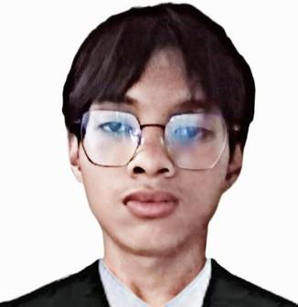**Aton, Kimpee**

**Student**

Enthusiastic and dedicated Information Technology student with a passion for technology and innovation. Eager to gain hands-on experience and apply classroom knowledge to real-world challenges. Known for being a fast learner, team player, and adaptable individual with strong problem-solving and analytical skills.

**CONTACT**

[k1mpeeaton06@gmail.com](mailto:k1mpeeaton06@gmail.com)

[**https://kimpeea.github.io/FinalProject/**](https://kimpeea.github.io/FinalProject/)

**EDUCATION**

**Global Reciprocal Colleges**

Bachelor of Information Technology

2nd Year

( 2023-2025 )

**Bagong Barrio Senior High School**

( 2022-2023 )

**Electron College of Technical Education**

( 2020-2021 )

**Bagong Barrio National**

High School

( 2016-2020 )

**SKILLS**

Collaborative Leadership Creative

Direction

Adaptability & Open-mindedness

Analytical Observation

**WORK EXPERIENCE**

**N/A**

**Isip, Jerick Rupert D.**

**Self-Taught Developer**

Self-taught and passionate about creating interactive digital experiences through games and software. Looking to contribute to real-world projects while continuing to grow in design, problem-solving, and development.

**Skills and Technologies**

*Comfortable with*:

* C/C++, Python, C3
* Linux (ArchLinux), Windows
* Git, Neovim/Vim.

*Familiar with*:

* HTML, CSS, Javascript
* C3, Java, Lua
* VSCode, Visual Studio

**Education**

**Global Reciprocal Colleges**

Bachelor of Information Technology

( 2023 - Present )

**Electron College of Technical Education**

Information and Computer Technology

Maria Clara High School

Cayetano Arellano Elementary School

79 Mabalacat St 6th Ave

Caloocan City

**Contact**

09957692367

*Primary Email*

[nexushastaken@gmail.com](mailto:nexushastaken@gmail.com)

*Secondary Email*

[jerickrupertisip@gmail.com](mailto:jerickrupertisip@gmail.com)

**Socials**

*Facebook Link*

<https://web.facebook.com/isip.jerick.rupert>

*Github Profile*

<https://github.com/NexushasTaken>

Discord

nexus.null

**SALIBIO, CRISTIAN PAUL L.**

*170.*

*Gen Evangelista St. Bagong Barrio Caloocan City*

*09271850702*

*cristiansalibio7@gmail.comail.com*

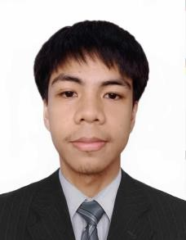

**OBJECTIVE**

As a student, I pride myself on being a responsible and organized individual. I am enthusiastic about embarking on my first professional experience and eager to contribute to a workplace environment that values dedication and precision.

**EDUCATIONAL BACKGROUND**

**College Bachelor of Science in Information Technology (BSIT)**

***Global Reciprocal Colleges GRC, 2024 – Present***

*GRC Building, Rizal Ave Ext, Grace Park East, Caloocan City*

**Senior High School Information and Communication Technology (ICT)**

***Electron College of Technical Education, 2019 – 2021***

*10th ave, Grace Park East, Caloocan City*

**Junior High School Bagong Barrio National High School, 2016 – 2020**

*De Castro Street, Bagong Barrio, Caloocan City*

**Elementary Bagong Barrio Elementary School**, **2010** **–** **2016**

*Malolos Ave. Bagong Barrio Caloocan City*

**PERSONAL DATA:**

Skill

* Empathic listener
* Self-possesion
* Diligent
* Flexible

D 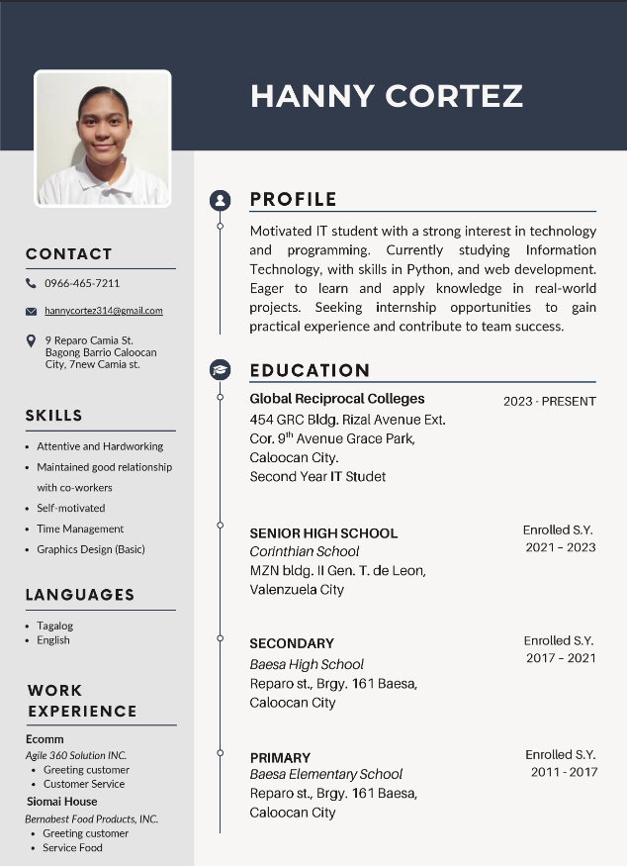

|  |  |  |
| --- | --- | --- |
|  |  | PERSONAL INFORMATION |
|  | Gender : Female  Age : 21  Date of Birth : November 12, 2003  Place of Birth : Fabella Memorial Hospital  Religion : Born again Christian  Nationality : Filipino |
| **Geraldyn R. castillano**  **OBJECTIVES**  To secure a position that leverages my technical skills, educational background, and collaborative abilities, with a focus on applying my knowledge in IT industry and grow professionally.   CONTACT PHONE: 09513710068  Email Address: castillanogeraldyn@gmail.com  Address: Blk 38 lot 6 ph-3 F1 J Dagat- dagatan  Lapu-lapu Ext. Barangay 12 Caloocan City |  | EDUCATION |
|  | **NAME OF SCHOOL SCHOOL TERM**    **ELEMENTARY : NINOY AQUINO ELEMENTARY SCHOOL 2010 – 2016 MAYA MAYA ST. MALABON CITY**    **JUNIOR HIGH SCHOOL : M.B.ASISTIO SR.HIGH SCHOOL 2016 – 2020 PAMPANO ST., KAUNLARAN VILLAGE, CALOOCAN CITY**  **SENIOR HIGH SCHOOL : IMELDA INTEGRATED SECONDARY SCHOOL 2021 – 2023 HASA-HASA ST. COR. LANGARAY ST., LONGOS, MALABON CITY**  **COLLEGE : GLOBAL RECIPROCAL COLLEGES 2023 - Present**  **GRACE PARK, CALOOCAN CITY** |
|  | PERSONAL SKILLS |
|  | * + **Passionate**   + **Responsible**   + **Self-Motivated**   + **Take up new challenges**   + **Good in Team work**   + **Hospitable**   + **Humble and Friendly** |